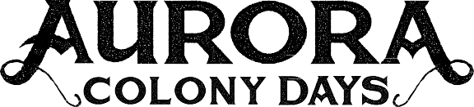
ENTRY FORM
2025 PARADE

1989 ~
36th
ANNIVERSARY

~ 2025
The Aurora Colony Days parade will take place on Saturday, August 9th, 2024 at 11:00 am. See reverse for parade rules and route map. Check-in begins at 8:30 am at Aurora City Park, 21074 Main St. NE. Please arrive no later than 10:30 am; judging of entries begins at 9:30 am. Please post a sign with the name of your entry on your float, bike, vehicle, etc.

Saturday, August 9th, 11:00 AM

Name of Entry
Description
Mark any that apply:
⃝ Motorized Vehicle ⃝ Towing Anything?
Describe
IMPORTANT: Debris collector must be part of your horse/pet entry.
⃝ Marching Group ⃝ Walking ⃝ Music ⃝ Horse ⃝ Pet

⃝ Will your entry make noise? ⃝ Do you intend to give anything away? (i.e., candy)

⃝ Check if this is your first time in Aurora’s parade
⃝ Special Considerations?
Describe
Judging: There are seven (7) Judging Categories: Best Theme, Best Spirit, Best Kids, Best Pet/Horse, Best Vintage Vehicle/Tractor, Grand Marshal Choice & Most Original Float.
Contact Person
Email Phone

Please email the completed form to assistant@ci.aurora.or.us , or you can mail or drop off your completed entry form to: Aurora City Hall, 21420 Main Street NE, Aurora, OR 97002
Your completed entry form must be received by Thursday, August 7th to be eligible for judging.
For more information on Aurora Colony Days festivities, visit: auroracolonydays.com facebook.com/auroracolonydays

DISCLAIMER
Signing of this entry and/or participation in the parade specifically waives any right of action by the participant against the City of Aurora, parade volunteers, sponsors, and Aurora Colony Days and its committees for any liability resulting from accidents, injuries, or other damages to persons, animals, or property while participating in the Aurora Colony Days parade and its related events. You are encouraged to make a copy of both sides of this form for your records.

Signature Date
(Parent/legal guardian must sign for minor)

Aurora Colony Days Parade Participation Rules

- Arrive beginning at 8:30 am, award judging beings at 9:30 am, parade starts promptly at 11:00 am.
- Check in at tent on Main Street (south of Bob’s Avenue).
- Post a sign with name of your entry clearly marked on your float, vehicle, bike, etc.
- All participants must keep pace with parade flow and abide by the designated parade route and ushers.
- Participants will begin in order of assigned parade line-up unless instructed otherwise by parade organizers.
- Children shall not be left unattended. An adult or an older child must accompany children under 7 years of age on the parade route.
- Candy can be passed out by walkers or handed out from vehicles. No candy shall be thrown onto the street.
- Participants handing out items (paper, free items, tokens, water bottles, etc.) during parade are responsible for cleaning up of items left on the streets of Aurora. This includes candy, solicitations, advertising, and campaign material.
- Horse and pet entries must be attended & under control by lead rope or lease at all times,
AND accompanied by a diligent debris collector before, during, and after the parade.
- Participants shall observe family-friendly dress, music, signage, language, dancing, etc.
- Parade organizers reserve the right to amend these rules at any time.

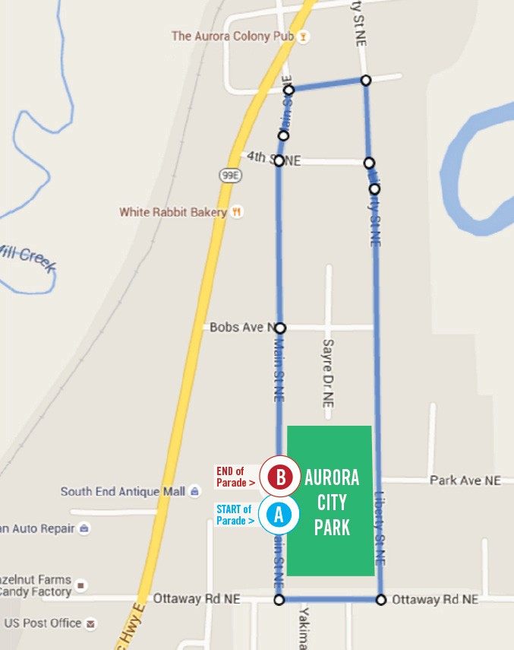
AURORA COLONY DAYS PARADE ROUTE
(approx. 1.12 miles)
START at 21074 MAIN Street NE, Aurora, at Aurora City Park (A on map).
Head SOUTH on MAIN Street NE toward OTTAWAY Road approx. 0.01 miles.
Turn left (EAST) onto OTTAWAY Road and travel approx. 0.1 miles.
Turn left (NORTH) onto LIBERTY Street and travel approx. 0.5 miles.
Turn left (WEST) onto 3rd Street and travel approx. 0.07 miles.
Turn left (SOUTH) onto MAIN Street and travel approx. 0.4 miles to return to Aurora City Park to the END of Parade (B on map).
For more information on Aurora Colony Days festivities, visit: http://auroracolonydays.com or https://www.facebook.com/AuroraColonyDays/

